**JESSORE UNIVERSITY OF SCIENCE & TECHNOLOGY**



**A Study and Design of a Belt Conveyor**

|  |
| --- |
| **Md. Delwar Hossain Chowdhury**  **Sk. Md. Zubayer-Al-Mahmud** |

**Department of Industrial & Production Engineering**

**Jessore University of Science & Technology**

**Jessore-7408, Bangladesh**

**November, 2015**

**A Study and Design of a Belt Conveyor**

A THESIS

BY

|  |
| --- |
| Md. Delwar Hossain Chowdhury ID:100724  Sk. Md. Zubayer-Al-Mahmud ID:100729 |

SESSION: 2010 – 2011

The thesis submitted to the department of Industrial and Production Engineering in partial fulfillment of the requirements for the degree

of

**Bachelor of Science in Industrial and Production Engineering**



**JESSORE UNIVERSITY OF SCIENCE AND TECHNOLOGY**

**JESSORE-7408, BANGLADESH**

**NOVEMBER, 2015**

The thesis titled “A Study and Design of a Belt Conveyor” submitted by **Md. Delwar Hossain Chowdhury**, Student No. 100724, Session- 2010-2011; Sk.Md. **Zubayer-Al-Mahmud**, Student No. 100729, Session- 2010-2011, has been accepted as satisfactory in partial fulfillment of the requirement for the degree of **Bachelor of Science in Industrial and Production Engineering**on November, 2015.

|  |
| --- |
| **Samrat Kumar Dey**  Assistant Professor  Department of Industrial & Production Engineering,  Jessore University of Science & Technology,  Jessore-7408. Bangladesh |

**Acknowledgments**

First of all we would like to thanks to supreme and almighty Allah that He has given us the opportunity to make a thesis paper on belt conveyor and helped us to complete our thesis.

We would like to give a big thanks to our honorable supervisor **Samrat Kumar Dey**, Assistant Professor, at Jessore University of Science and Technology in the department of Industrial and Production Engineering for his continuous guidance over the period of the thesis. Without some of his suggestions and instructions this thesis would not have been successful. He also helped us to solve complicated things so that we are able to complete our thesis paper within the given period.

We are sincerely grateful to the faculty members **Dr. A. S. M. Mojahidul Haque** , Assistance Professor and Chairman; **Rubayet Karim**, Assistance Professor; **Pobitra Kumar Halder**, Assistant Professor; **Md. Sohel Parvez**, Assistant Professor; **Sarojit Kumar Biswas**, Lecturer; **Chitralekha Karmokar**, Lecturer at Jessore University of Science and Technology in the department of Industrial and Production Engineering who made this thesis paper successful one, are specially thanked by us. We are highly thankful for their help at various stages of the work.

We are deeply grateful to our parents for providing mental strength and courage to continue this thesis work smoothly and the source of inspiration throughout the entire thesis.

**ABSTRACT**

This thesis focuses on the improved design and manufacturing of a belt conveyor. Belt conveyors are not only used to transport bulk materials but also used for transporting unit load or product in a specific distance successfully. Belt conveyors should use only the highest feature first-class belting products, which reduces belt stretch and tension. In certain applications they can also be used for static accumulation or cartons. Belt conveyors are designed in such a way that it can assist fast and safe loading and unloading with least human obstruction. Belt conveyor system can be engaged for easy conduct of materials beyond human aptitude in terms of weight and height. The design and considerations of the belt conveyor system is based in terms of size, length, capacity and speed, roller diameter, power and tension, location and arrangement of pulley and so on. In essence, we emphasize on improving the design and reducing the manufacturing cost of the belt conveyor as well as fast, safe and efficient material handling and transportation system.

**Table of Content**

**Acknowledgements ----------------------------------------------------------------Vi**

**Abstract -----------------------------------------------------------------------------Vii**

**List Of Figures ----------------------------------------------------------------------xi**

**List Of Tables ----------------------------------------------------------------------xii**

**Terms And Definitions ----------------------------------------------------------xiii**

1. **Introduction -------------------------------------------------------------------------------02**
   1. **Background---------------------------------------------------------------------------------02**
   2. **Application----------------------------------------------------------------------------------03**
   3. **Advantages of belt conveyor-------------------------------------------------------------03**
   4. **Drawbacks of belt conveyor--------------------------------------------------------------04**
   5. **Objectives------------------------------------------------------------------------------------05**
2. **Literature review -----------------------------------------------------------------------07**
   1. **Conveyor-----------------------------------------------------------------------------------07**
   2. **Belt Conveyor ----------------------------------------------------------------------------08**
      1. **Flat Belt Conveyor----------------------------------------------------------------08**
      2. **Telescoping Belt Conveyor------------------------------------------------------09**
      3. **Steel Hinge Belt Conveyors-----------------------------------------------------09**
   3. **Types of Belts-----------------------------------------------------------------------------11**
   4. **Materials used for Belts----------------------------------------------------------------11**
   5. **Driving device----------------------------------------------------------------------------13**
   6. **Idler----------------------------------------------------------------------------------------14**
   7. **Bearing------------------------------------------------------------------------------------15**
   8. **Take- up system-------------------------------------------------------------------------15**
      1. **Function of take-up system-----------------------------------------------------15**
      2. **Types of Take-up system--------------------------------------------------------16**
         1. **Manual take-up-----------------------------------------------------------------16**
         2. **Automatic take up systems---------------------------------------------------16**
3. **Methodology ----------------------------------------------------------------------------18**
   1. **Design Approach------------------------------------------------------------------------18**
   2. **Calculation of Belt Conveyor----------------------------------------------------------19**
      1. **Belt capacity------------------------------------------------------------------------19**
         1. **Belt width-------------------------------------------------------------------------19**
         2. **Belt speed-------------------------------------------------------------------------20**
         3. **Dynamic angle of repose-------------------------------------------------------20**
         4. **General procedure--------------------------------------------------------------20**
      2. **Belt Power and Tensions--------------------------------------------------------21**
         1. **Tensile force of belt conveyor in steady state-----------------------------22**
         2. **Tensile force at head drive----------------------------------------------------22**
         3. **Tension at starting state-------------------------------------------------------22**
   3. **Roller diameter---------------------------------------------------------------------------23**
   4. **Pulley Diameter --------------------------------------------------------------------------23**
   5. **Motor Power-------------------------------------------------------------------------------24**
   6. **Results --------------------------------------------------------------------------------------25**
4. **Design Of The Components Of Belt Conveyor---------------------------------------27**
5. **Study OF Failure Analysis--------------------------------------------------------34**

**5.1 Drum and Pulley Failure--------------------------------------------------------------34**

* + 1. **Typical failure and processing---------------------------------------------------34**
    2. **Fracture in collapsed heavy-duty pulley---------------------------------------34**
    3. **Conveyor Pulley Shaft Failures--------------------------------------------------34**
    4. **Analysis of conveyor pulley using FEM----------------------------------------34**
    5. **Fatigue Failures of Welded Conveyor Drum----------------------------------34**
    6. **Fatigue in the shell of a conveyor drum-----------------------------------------35**
  1. **Study of Belt design and its failure----------------------------------------------------36**
     1. **Vibrations with Low and Time-Varying Velocity-----------------------------36**
     2. **Conditions for field vulcanizing with a better capability of elongation---36**
     3. **Eco-design of non-metallic layer composites for belts------------------------36**
     4. **Belt Tension around a Drive Drum-----------------------------------------------36**
  2. **Accident frequency-------------------------------------------------------------------------37**
     1. **According to conveyor location---------------------------------------------------37**

**5.3.2 Worker Activity----------------------------------------------------------------------37**

1. **Maintenance and Safety of Belt Conveyor-------------------------------------40**
   1. **Maintenance (Repair)----------------------------------------------------------------------40**
   2. **Adjustment During Operation-----------------------------------------------------------40**
   3. **Lubrication-----------------------------------------------------------------------------------40**
   4. **Guards And Safety Devices---------------------------------------------------------------41**
   5. **Inspections-----------------------------------------------------------------------------------41**
   6. **Cleaning--------------------------------------------------------------------------------------41**
   7. **Safety Warning-----------------------------------------------------------------------------41**
   8. **Maintenance Schedules-------------------------------------------------------------------42**
      1. **Daily Maintenance------------------------------------------------------------------42**
      2. **Weekly Maintenance---------------------------------------------------------------42**
      3. **Monthly Maintenance--------------------------------------------------------------42**
      4. **Quarterly Maintenance------------------------------------------------------------43**
      5. **Semi-Annual Maintenance--------------------------------------------------------43**
      6. **Annual Maintenance ---------------------------------------------------------------43**
2. **Discussion------------------------------------------------------------------------------------45**
3. **Conclusion-----------------------------------------------------------------------------------47**

**References----------------------------------------------------------------------------------------48**

**List of Figures**

**Figure 2.1:** Flat belt conveyor**---------------------------------------------------------------09**

**Figure 2.2:** Telescoping belt conveyor**-----------------------------------------------------09**

**Figure 2.3:** Steel hinge belt conveyor**------------------------------------------------------10**

**Figure 2.4:** Types of belts**-------------------------------------------------------------------11**

**Figure 2.5:** Leather belts layer **-------------------------------------------------------------12**

**Figure 2.6:** Trough idler**---------------------------------------------------------------------14**

**Figure 2.7:** Flat idler**-------------------------------------------------------------------------14**

**Figure 2.8:** Rubber ring impact idler**------------------------------------------------------14**

**Figure 2.9:** Centering idler**-----------------------------------------------------------------15**

**Figure 3.1:** Belt conveyor **-----------------------------------------------------------------19**

**Figure 4.1:** Support table**-------------------------------------------------------------------27**

**Figure 4.2:** Pulley**----------------------------------------------------------------------------28**

**Figure 4.3:** Support roller**-------------------------------------------------------------------29**

**Figure 4.4:** Tension device**-----------------------------------------------------------------30**

**Figure 4.5:** Belt**-------------------------------------------------------------------------------30**

**Figure 4.6:** Assembly of rollers and pulleys**----------------------------------------------31**

**Figure 4.7:** Assembly with belt**-------------------------------------------------------------31**

**Figure 4.8:** Belt Conveyor-**------------------------------------------------------------------32**

**Figure 5.1:** Percentage in causes of drum failure in Belt Conveyor System **------------35**

**List of Tables**

**Table 2.1:** Summary of belt conveyor**-----------------------------------------------------------10**

**Table 3.1:** Value of various parameters**------------------------------------------------------25**

**Table 5.1:** Accident percentage according to conveyor location **----------------------------37**

**Table 5.2:** Accident percentage according to worker activity **-------------------------------37**

**Terms and definitions:**

Bed Section – The conveyor frame is that which supports the conveyor’s belt, drive, end units, carrying surface/rollers, etc.

Belt Cover – A rubber or PVC coating applied to a conveyor belt to protect the belt carcass and/or provide special carrying capacities for the belt.

Belt Sag – Lack of tension or tautness in the conveyor belt that causes it to droop in areas between supporting members.

Belt Tension – The results of force applied to the conveyor that causes or trends to cause stress or stretching of the belt. All belts must be tensioned to some extent to provide proper driving force and tracking.

Belt Tracking – The path followed by the belt as it runs on the conveyor and around the conveyor pulleys.

Belt Wrap – The amount of contact between a belt and a pulley, or roller, measured in degrees.

Brake – A friction device used to bring conveyor components to a controlled stop and

/or prevent them from moving once stopped.

Bearing block – The block or housing that contains or supports a bearing

Drive Pulley – The pulley that is connected to the drive gearbox by the drive chain and sprocket transmitting the rotational force provided by the arrangement to the conveyor belt. Driving force to the conveyor belt is provided by the amount of belt wrap on the drive pulley and the vulcanized lagging provided on the pulley.

Drive Sprocket – The sprockets used in the power transmission arrangement found in the conveyor drive unit. The sprocket sizes are selected to provide some mechanical advantage and give the desired conveyor speed from a given output RPM of the gearbox.

Frame – A structure supporting the machinery components of a conveyor.

Friction – Resistance to relative motion between two bodies in contact caused by the surface characteristics of the bodies at the point or area of contact, and the contact pressure.

Gravity Roller Conveyor – A series of rollers supported in a frame over which objects are advanced by gravity. Rollers are not powered by an outside force.

Head Pulley – A pulley used at the terminal end of the conveyor toward which the commodity is being conveyed.

Head end – The end of the conveyor toward which the commodity is being conveyed.

Power Transmission Belt – A belt that transmits power or motion from one rotating part to another.

Power Transmission Parts – Those parts or components by which power produced by the motor or gear, motor is conducted and applied to run the drive pulley of a conveyor.

Pulley – Consist of a steel tube with end plated, taper lock mounting hubs and bushing, and a steel shaft. Used for drive pulley, end pulleys and take-up pulleys.

Take-up Device– The arrangement of parts that are applies tension to the conveyor belt, consisting of a take-up pulley or roller and a means for adjusting its position to create longitudinal stress in the belt.

V-belt – A drive belt having a trapezoidal cross section for operation degrees over grooved sheaves. Its shape permits wedging contact between belt side and grooves walls for transmission of power

OSHA – Occupational Safety and Health Administration

FEM - finite element modeling

**CHAPTER 1**

**1. Introduction:**

At the present time, the trendiest use of conveyor system in industries is to transfer unit load and bulk material. Conveyor systems are materials handling apparatus, where they are used first and foremost to transfer load from one area to another proficiently, reducing the need for manual involvement in the process. Some industries in which unit loads are conveyed include agriculture, chemical, pharmaceuticals, paint manufacturer, and various factories. [1]

The suitable conveyor for moving small lightweight items such as packet, box, carton, container or bottle in industries are light duty belt conveyor. This conveyor is not heavy but it must be suitable placed to transfer those things that are needed. The conveyor also must have a controller to control the conveyor and signal.

* 1. **Background:**

Transfer of bulk materials by conveyor belts in ancient times around 1795, although the greater parts of these early iterations were used to move grains in excess of very short distances. The first belt conveyor systems were very straightforward and consisted of a leather, canvas or rubber belt traveling over a flat wooden bed. By the turn of the 20th century, conveyors were being used for other applications as well, and overhead trolleys and belt conveyors were moving items in manufacturing plants. Hymle Goddard of Logan Company received the first patent for roller conveyor in 1908, but the conveyor business didn't truly beautify until a few years later. Automotive production utilized powered and free conveyor lines beginning in 1919, and throughout the 1920s, conveyors became a fashionable tool for handling mass produced goods within factories. In 1947, the first standards involving conveyor safety were developed by the American Standards Association. In the 1970s, conveying systems often generated high noise levels. One of OSHA's first priorities upon its creation in 1970 was curtailing conveyor noise. Often, conveyors had to be replaced with completely new systems significantly before their expected failure. During the 1970s, 1980s and 1990s, engineers of conveyor apparatus developed and perfected internally powered conveyor rollers and motorized pulleys that eliminated costly maintenance needs. New configurations and technological innovations have kept conveyor systems on automated material handling systems. But now a day, suitable conveyor takes high price than effectiveness. So it is needed to take step to reduce manufacturing cost with suitable design for best uses. Changes in technology are certain to keep the industry in motion as users look for faster throughput diverted sorting. So conveyor can popular for best design on benefit of uses and manufacturing cost. [2]

**1.2 Application:**

At present, a broad range of material can be handled such as abrasive, wet, dry, sticky or dirty material. Longer distances can be covered more cost-effectively than any other transportation. Belt conveyor has some other applications such as:

1. Industrial production
2. Logistics and airports
3. Tobacco
4. Textile
5. Food industry
6. Printing and packaging
7. Paper mills
8. Marble and ceramics
9. Bakeries
10. Ship yards

**1.3 Advantages of belt conveyor:**

Belt conveyors are capable of handling a wide range of bulk materials from very fine to large lump sizes. Extremely fine materials such as Portland cement are loaded at terminals using belt conveyors. Large lump size materials such as coal are transported from mines by using belt conveyors.

1. Belt conveyors can discharge materials up to 11,000 tons per hour. It can also be designed for batching operations or to convey a small amount of material between various processes.
2. A belt conveyor can convey material horizontally, incline or a combination of both. It is common to use a single belt conveyor to transport material horizontally in a certain distance.
3. Belt conveyor is suitable to convey bulk materials, unit load, carton or any other types of heavy or light weight in many industries.
4. Belt conveyors need less horsepower to operate than other types of conveyors. Bulk materials are carried on top of the belt and stay motionless, therefore requiring much less energy to move.
5. According to the structure of belt conveyor it is one of the lightest forms of conveying machine.
6. The belt conveyor can take on for extraordinary purposes (fire resistant, wear resistant, deterioration resistant, high angle compromise etc.) and can be integrated with other apparatus.
7. Less labor is required for the process and protection of belt conveyor system.
8. Belt conveyor can be used in underground mine transfer lean seams as it eliminates the rock works that might otherwise be required to gain carrying height.
9. It is moderately cheaper and supporting structures can be used for many others unworkable structures such as crossing rivers, streets and valleys. [3,4]

**1.4 Drawbacks of belt conveyor:**

1. Proper design of the transportation and loading points are required.
2. To protect the belt from getting spoiled by operational troubles, numbers of shielding strategy have to be integrated.
3. For the effective pull of the belt, higher initial tension is required (40-200% of functional pull).
4. It is one of the major problems in conveying muggy substances which are required cleaning and discharging so that productivity is become poor.[5]

**1.5 Objectives:**

* To study the efficiency of the belt conveyor.
* To study various parameters and design criteria of belt conveyor that affects belt capacity and efficiency.
* To study how to reduce power consumption of belt conveyor.
* To study the failure criteria in the belt conveyor.

**CHAPTER 2**

**2. Literature review**

Some of the recent development of belt conveyor had been carried out as:

1. Devendra Kumar and R.K. Mandloi they had shown the belt conveyor design modification and latest technologies or methodologies used in different applications to reduce failures, maintenance cost and equipment related fatal accidents that occur during operation on their review paper.
2. Shalom Akhai and Harpreet Singh they werefocused on the reduction of material spillage from a belt conveyor leading to excessive dust emission, frequent maintenance and repair of conveyor, Loss of power and reduction in material transport efficiency.
3. Marcus Haines: Hisexisting literature was used to determine the major sources of noise and vibration. Careful material selection was conducted to determine the most suitable material to use in an idler roller, with the aims of minimizing weight and the noise emitted.
4. Methodology for selection of belt conveyor drive units numbers by technical - economical analysis are including: Tension forces, Power of belt conveyor, Costs for belt, Costs for power and reducers, Total cost for belt conveyor system that was analyzed by Zoran Despodov, Stojance Mijalkovski, Vanco Adziski and Zoran Panov)

**2.1 Conveyor:**

Conveyer is a type of material handling equipment basically used to transfer large quantity of material from one area to other area proficiently and to decrease the requirement for manual involvement in the process. Conveyor system normally used more in industries operations, warehouse tasks, manufacturing, pharmaceuticals, commercial and distributive applications and other applications where large amounts of material necessity to move quickly, safely, proficiently and efficiently. For example in industries, conveyor use to convey the product to increase the productivity and to reduce the movements. Conveyers can be divided as powered conveyors or non-powered conveyors. In industries today, we have variety of conveyor such as, belt conveyor, roller conveyor, skate-wheel conveyors, chain conveyors, and in-floor towline conveyor.

Conveyor gives more advantages such as:-

1. More proficient and efficient usage of space
2. Decrease manual labor involvement
3. Increase productivity
4. More competent production process
5. Reliable and cost effective and
6. Reduce the member of staff movement [1]

**2.2 Belt Conveyor:**

A belt conveyors is a continuous loop of material involve of two or more pulleys. The pulley is used to move the belt and the material on the belt forward and reverse. One or both of the pulleys must have a powered to drive the belt. The driving pulleys act as an activator to move the belt forward and reverse. Then, the idle roll is used beside the driving pulley just to follow the drive roll. The movement of driving pulley is control by DC motor. The belt conveyors are available in two common forms. First, the flat belts for unit load, pallets, individual parts, or even certain types of bulk materials and second, troughed belts for bulk material. The most popular belt conveyors types are flat belt conveyor, telescoping belt conveyor, trough belt conveyor and steel hinge belt conveyors. [1]

**2.2.1 Flat Belt Conveyor:**

A flat belt conveyor is a class from belt conveyor. A flat belt conveyor is normally use for light and medium weight loads between operations, departments, levels, and buildings. It is mainly useful when an incline or decline include in the conveyor path. Because of the friction between the belt and the load, the belt conveyor affords significant control over the orientation and placement of the load. However friction also prevents smooth growth, merging, and sorting on the belt. The belt is normally either roller or slider bed supported. If small and irregularly shape an item is being handled, then the slider bed would be use, otherwise, the roller support is usually more cost-effective. This conveyor is suitable used for industrial area, pharmacy area, various laboratories and workshops. [1]

|  |
| --- |
|  |
| **Figure 2.1:** Flat belt conveyor.[5] |

**2.2.2 Telescoping Belt Conveyor:**

A telescoping belt conveyor is a type of flat belt conveyor that functions on telescopic slider beds. Telescoping belt conveyor is popular driver at receiving and shipping docks where the conveyor is extend into inbound or outbound trailers for unloading or loading. This conveyor is not suitable to use for pharmacy area. [5]

|  |
| --- |
| C:\Users\SHAZIB CHOWDHURY\Desktop\2.2.PNG |
| **Figure 2.2:** Telescoping belt conveyor. [5] |

**2.2.3 Steel Hinge Belt Conveyors:**

Basically a steel hinge belt conveyor is easily to transport the material such as metal stamping, quenched parts, hot forging, flash, wet or dry chips, turnings, borings, frozen rubber parts, fasteners, and castings. The steel hinge belt conveyor is also suited for removing wood, plastic, rubber and steel parts from high-speed automatic presses or other machinery. The conveyors belt is created of heavy-gauge steel with rollers, and rods. The belt is driven by roller chain on both sides and bears all tension to allow the belt to lift freely. [5]

|  |
| --- |
|  |
| **Figure 2.3:** Steel hinge belt conveyor. [5] |

In belt conveyor, it can be more categorized as flat belt conveyor, steel hinge belt conveyors and telescoping belt conveyor. The advantages of belt conveyor described in Table 2.1. [1], [5]

**Table 2.1:** Summary of belt conveyor

|  |  |  |
| --- | --- | --- |
| No | Types of belt conveyor | advantages of belt conveyor |
| 1 | Flat belt conveyor | (i) Friction are prevents smooth growth, merging, and sorting on the belt.  (ii) The belt is generally either roller or slider bed supported.  (iii) The roller support is usually more cost-effective. |
| 2 | Telescoping belt conveyor | (i) Can drive at receiving and shipping docks where the conveyor is extended into inbound or outbound trailers for unloading or loading. |
| 3 | Steel hinge belt conveyors | (i) Can transport the material such as metal stamping, quenched parts, hot forging, flash, wet or dry chips, turnings, borings, frozen rubber parts, fasteners, and castings.  (ii) Suited for removing wood, plastic, rubber and steel parts.  (iii) Can operate from high-speed automatic presses or other machine. |

**2.3 Types of Belts:**

Though there are many types of belts used these days, yet the following are important from the subject point of view:

* 1. **Flat belt:** The flat belt, as shown in Fig. 2.4 (*a*), is mostly used in the factories and workshops, where a moderate amount of power is to be transmitted, from one pulley to another when the two pulleys are not more than 8 metres apart.
  2. **V-belt:** The V-belt, as shown in Fig. 2.4 (*b*), is mostly used in the factories and workshops, where a moderate amount of power is to be transmitted, from one pulley to another, when the two pulleys are very near to each other.
  3. **Circular belt or rope:** The circular belt or rope, as shown in Fig. 2.4(*c*), is mostly used in the factories and workshops, where a great amount of power is to be transmitted, from one pulley to another, when the two pulleys are more than 8 meters apart.[6]

|  |  |  |
| --- | --- | --- |
| **C:\Users\workgroup\AppData\Local\Microsoft\Windows\INetCache\Content.Word\Flat belt.png** | **C:\Users\workgroup\AppData\Local\Microsoft\Windows\INetCache\Content.Word\V-belt.png** | **C:\Users\workgroup\AppData\Local\Microsoft\Windows\INetCache\Content.Word\Circular belt.png** |
| (*a*) Flat belt. | (*b*) V-belt. | (*c*) Circular belt. |
| **Figure 2.4:** Types of belts.[6] | | |

**2.4 Materials used for Belts:**

The material used for belts and ropes must be heavy-duty, strong, flexible, and durable. It must have a high coefficient of friction. The belts, according to the material used, are categorized as follows:

1. **Leather belts:** The most essential material for the belt is leather. The best leather belts are made from 1.2 metres to 1.5 metres long strips cut from either side of the back bone of the top grade steer hides. The hair side of the leather is smoother and harder than the flesh side, but the flesh side is stronger. The fibers on the hair side are perpendicular to the surface, while those on the flesh side are interwoven and parallel to the surface. Therefore for these reasons, the hair side of a belt should be in contact with the pulley surface, as shown in Fig. 11.2. This gives a more intimate contact between the belt and the pulley and places the greatest tensile strength of the belt section on the outside, where the tension is maximum as the belt passes over the pulley.

|  |  |
| --- | --- |
| C:\Users\workgroup\AppData\Local\Microsoft\Windows\INetCache\Content.Word\Single layer belt.png | C:\Users\workgroup\AppData\Local\Microsoft\Windows\INetCache\Content.Word\doublelayer belt.png |
| (*a*) Single layer belt. | (*b*) Double layer belt. |
| **Figure 2.5:** Leather belts layer.[6] | |

The leather may be either oak-tanned or mineral salt tanned *e.g*. chrome tanned. In order to increase the thickness of belt, the strips are cemented together. The belts are specified according to the number of layers e.g. single, double or triple ply and according to the thickness of hides used e.g. light, medium or heavy. The leather belts must be periodically cleaned and dressed or treated with a compound or dressing containing neat foot or other suitable oils so that the belt will remain soft and flexible.

1. **Cotton or fabric belts:** Most of the fabric belts are made by folding canvass or cotton duck to three or more layers (depending upon the thickness preferred) and stitching together. These belts are woven also into a strip of the preferred width and thickness. They are impregnated with some filler like linseed oil in order to make the belts water proof and to prevent damage to the fibers. The cotton belts are cheaper and suitable in warm climates, in damp atmospheres and in exposed positions. Since the cotton belts require little attention, therefore these belts are mostly used in farm machinery, belt conveyor etc.
2. **Rubber belt:** The rubber belts are made of layers of fabric saturated with rubber composition and have a thin layer of rubber on the faces. These belts are very flexible but are quickly destroyed if allowed to come into contact with heat, oil or grease. One of the principal advantages of these belts is that they may be easily made endless. These belts are found suitable for saw mills, paper mills where they are exposed to moisture.
3. **Balata belts:** These belts are like to rubber belts except that balata gum is used in place of rubber. These belts are acid proof and water proof and it is not affected by animal oils or alkalis. The balata belts should not be at temperatures above 40°C because at this temperature the balata begins to soften and becomes sticky. The strength of balata belts is 25 percent higher than rubber belts.[6]

**2.5 Driving device:**

Driving device is the power transmitting mechanism of a belt conveyor. It is made up of an electromotor, coupling, reducer and driving pulley and so on. According to different using conditions and working requirements, the drive mode of a belt conveyor can be grouped to single-motor driving, multi-motor driving, single-pulley driving, and double-pulley driving and multi-pulley driving.

Single motor and single pulley driving is accepted by a belt conveyor. The driving device is installed at the discharge point which is located at the conveyor head. When the power is big, a single motor and double-pulley driving is used, precisely, one motor has two driving pulleys, and the two pulleys are connected by a pair of exposed gear which has the same number of teeth. The pulleys can be categorized into two types:

1. Driving pulleys and
2. Return pulleys.

The belt is driven by friction which is produced by pulley’s surface and belt’s surface because of the function of driving pulley and the movement direction of the belt is changed at the same time.

Driving pulley is the main component of transmitting power. In order to transmitting sufficient power, sufficient friction must be provided from the belt and pulley. According to the theory of friction transmission, the methods of increasing friction between the conveyor belt and the pulley and augmenting the wrap angle can be adopted to ensure enough driving power when a driving device necessities to be chosen. Usually, when a single pulley is used, wrap angle can be 180-240; when double-pulley is used, the wrap angle can reach 360-480. Double-pulley driving can enhance the conveyor’s traction greatly, so it is often used especially when the transport distance is long. [7]

**2.6 Idler:**

Idler is the assistant device for belt and cargo of a belt conveyor. Idlers move as the belt moves so as to decrease the running resistance of the conveyor. Idler’s qualities depend on the usage of the belt conveyor, particularly the life span of the belt. However, the maintenance costs of idlers have become the major part of the conveyor’s operating costs. Hence, idlers need to have realistic structure, durability in use, small ratio of steering resistance, reliability, and dust or coal dust cannot get in bearing, due to which the conveyor has a small running resistance, saves energy and prolongs the service life.

Idlers can be divided into trough idlers (Figure 2.6), flat idlers (Figure 2.7), impact idlers (Figure 2.8) and centering idlers (Figure 2.9) according to the function. [7]

|  |
| --- |
|  |
| **Figure 2.6:** Trough idler |
|  |
| **Figure 2.7:** Flat idler |
|  |
| **Figure 2.8:** Rubber ring impact idler |
| H:\cen ideler.PNG |
| **Figure 2.9:** Centering idler |

**2.7 Bearing:**

The purpose of a bearing is to support a load to permitting relative motion between two components of a machine. The bearings have the wide of variety that use spherical balls or some other type of roller between the stationary and the moving elements. Bearing have many type such as single-row, deep-groove ball, double-row, deep-groove ball, angular contact, cylindrical roller, needle, spherical roller, and tapered roller. Fundamentally type of bearing use to supports a rotating shaft, resisting purely radial loads or a combination of radial and axial load. Some of the bearings design to carry only thrust loads. Most bearing uses in applications involve the rotation, but some of bearing is used in linear motion applications.

Deep-Groove Ball bearing can be divided for two types:

1. Single-row and
2. Double-row. [8]

**2.8 Take- up system:**

**2.8.1 Function of take- up system:**

• Adjust the proper tension

• Absorb any stretching along belt longitudinal axis

• Store a small amount of belt length as spare

• Allow releasing belt tension for maintenance and repairing jobs

**2.8.2 Types of Take-up system:**

1. Manual
2. Automatic

**2.8.2.1 Manual take-up system:**

• Compact and inexpensive

• adjusted by screw, spring, ratchet or jack

• Relies on operator judgment

• Needs periodic adjustments

• Normally located opposite to drive side

• Suitable for very short belts

• Could be in /off line of belt plane

• Normally located opposite to drive end

• Mounted in- line or off- line of belt

**2.8.2.2 Automatic take-up systems:**

• Pneumatically

• Hydraulically

• Electrically

• By gravity

Gravity type is most common used for economical and effective than any other Automatic take up systems. It is installed horizontally or vertically with self-adjusting and anywhere on the return line. It is desirable to locate close to drive for quick reaction [9]

**CHAPTER 3**

**3. Methodology**

**3.1 Design Approach:**

To make the material handling system useful and more effective, generally the guidelines are followed:

1. The belt conveyor system should be designed for continuous flow of material (idle time should be zero).
2. Ensure that the equipment should be less costly, flexible and sustain the standard of equipment.
3. Material flow system should be run with gravity.
4. The ratio of the dead weight to the payload of material handling equipment should be least amount.

To increase the efficiency of the belt conveyor system it is not only important to select accurate dimension of the belt conveyor components but also determine the significant parameter standards of the belt conveyor. Some of the components are: Conveyor belt, pulley, motor, rollers etc. The design of a belt conveyor system hooked on description of the followings:

1. Belt capacity and Dimension
2. Belt speed
3. Belt power and tension
4. Roller diameter
5. Pulley diameter
6. Idler spacing
7. Motor
8. Maximum loading capacity [10]

|  |
| --- |
| **belt conveyor** |
| **Figure 3.1:** Belt conveyor |

**3.2 Calculation of Belt Conveyor:**

The calculation of the belt conveyor is the evaluation of the capacity, tension of the belt as well as the effective pull of the belt conveyor. It is also the evaluation of the power of the drive pulley and motor. We have made our calculation as consider the weight of the conveyed goods 4kg, volume of the goods, the density of the goods and the cross sectional area as 0.0016. Detail calculation is as follows:

**3.2.1 Belt capacity:**

Belt capacity is depend further on some inter-related factors:

**3.2.1.1 Belt width:**

The belt width must be sufficient by containing and accepting the load of the material onto the belt whether it is of mixed large lump size or fine materials or unite load. The determination of belt width is largely a function of the quantity of conveyed materials or goods which is indicated by the design of the conveying belt.

**3.2.1.2 Belt speed:**

Belt speed is depended significantly on loading, discharge and transfer arrangements, lump sizes, maintenance standards etc.

**3.2.1.3 Dynamic angle of repose:**

“Angle of surcharge” is one of the most key characteristics in decisive carrying capacity as it directly governs the cross sectional area of material on the belt and hence the volume being conveyed. It is also known as dynamic angle of repose. Surcharge angle is always less than angle of repose. It depends on friction between the belt and the material and how the material is loaded.

**3.2.1.4 General procedure:**

The capacity is the product of speed and belt cross sectional area. Generally, belt capacity () is given as:

**Belt Capacity (C) = 3.6 × A × V × ρ**……………………… (1)

Where:

A= belt sectional area (0 );

ρ= material density ();

And V= belt speed ()

C= 0.9216 ()

The mass of material Mm (live load) per meter (kg/m) loaded on a belt conveyor is given as:

**Mm =**……………………… (2)

Where:

C= Conveyor capacity (); and

V= belt speed (1).

Mm.256 [11]

**3.2.2 Belt Power and Tensions:**

If the length of the belt is required longer, then the power for the conveyor will also be required much more and if higher the distance of the convey material, the higher the magnitude of power is required. The power Pp (W) at drive pulley drum is:

**=** ……………………… (3)

Where:

: Effective belt pull (N);

V: Belt speed 1.00); [11]

Now**, FU=**……………………… (4)

Where:

= Friction coefficient when running over roller (0.033)

= Acceleration due to gravity (9.81)

= Mass of the goods conveyed over the entire length conveyed (total load) (16 kg)

= Mass of the belt (12 kg)

= Mass of all rotating drums (except for drive pulley) (39 kg)

= 21.7 Ns

So the power at drive pulley is:

= 0.0217 W

Maximum belt pull is:

**=;** ……………………… (5)

Where:

= Effective Pull (21.7 N)

= Factor to the drive pulley (1.2)

So the maximum belt pull is 26.04 N [12]

The belt of the conveyor is always experience tensile load due to the rotation of the electric drive and mass of the conveyed materials. The belt tension must be great enough to prevent slippage between the drive pulley and the belt [13].

**3.2.2.1 Tensile force of belt conveyor in steady state:**

**= 2** ……………………… (6) and

**F**……………………… (7)

Where:

= tensile force of pulley

(Each side)

= effective pull (21.7 N) and

= Minimum belt pull (4.34 N)

So the tensile force = 19.53 N [12]

**3.2.2.2 Tensile force at head drive at steady state:**

**=** …………………… (8) and

**=**……………………… (9)

Where:

= Maximum belt pull (26.04 N)

= Minimum belt pull (4.34 N) and

So the tensile force at head drive is = 30.38 N

**3.2.2.3 Tension at starting state:**

**=** ……………………… (10)

Where:

=Tensile force at head drive (30.38 N)

= Start up factor (1.08)

So the tension remaining to start the conveyor is 32.8 N. [11]

**3.3 Roller diameter:**

The roller support belt and facilitates easy as well as free rotation of the belt conveyor in all direction. The correct choice of roller diameter must take into consideration the belt width [14]. The relationship between the maximum belt speed, roller diameter and the relative revolution per minute is given as:

……………………… (11)

Where:

n= no of revolution per minute;

D= roller diameter (mm); and

V= belt speed ()

The belt width is designed as 400 mm, the belt speed is 1.00 m/s, the roller diameter is therefore designed as 38 mm [14].

From equation 9, the no of revolution per minute n= 502 rpm.

The conveyor length= 2 (m)

Belt basic lengthlength along conveying route= 4 (m)

**3.4 Pulley Diameter:**

Pulleys are manufactured in a wide range of sizes. The selection of pulley takes into account the wrap angle (240), belt speed (1 m/sec), method of belt strain, belt tension T, belt width (400mm) and type of splice of the conveyor belt. The pulley diameter is obtained from standard value of the catalogue.

Pulley wraps length at terminals= 2πD [11].

Where:

Diameter of pulley = (150 mm)

Pulley wraps length at terminals= 0.942 m.

Drive pulley can be lagged to increase friction and improve communication between belt and pulley. [15] Elastic lagging helps to keep pulley clean so as to increase duration of friction while grooved lagging helps in removal of moisture so as to improve friction.

**The power (W) at drive pulley is**:

Recall equation (3)

Where:

: Effective pull at the drive pulley (21.7 N);

V: Belt speed (1.00); and

= 0.0217 W

**3.5 Motor Power:**

The minimum motor power for sizing of the motor is

**=**……………………… (12)

Where:

=Minimum motor power (W);

=Power at drive pulley (0.0217W); and

η:Efficiency of the motor (0.7)

=0.031 W. The next standard motor greater than will be sufficient [16], [4]

A standard motor of .5 HP is chosen.

**3.6 Results:**

**Table 3.1:** Value of various parameters

|  |  |  |
| --- | --- | --- |
| **No** | **Parameter** | **Values** |
|  | Belt width (mm) | **400** |
|  | Length of Conveyor (m) | **2** |
|  | Basic belt length (m) | **4** |
|  | Belt speed (m/sec) | **1** |
|  | Conveyor capacity (tons/hr) | **0.9216** |
|  | Belt tensile force at steady state (N) | **19.53** |
|  | Belt tension while starting (N) | **32.8** |
|  | Load due to materials conveyed (kg/m) | **0.256** |
|  | Power at drive pulley (W) | **0.0217** |
|  | Motor power (W) | **0.031** |
|  | Effective pull (N) | **21.7** |
|  | Roller diameter (mm) | **38** |
|  | Pulley diameter (mm) | **150** |
|  | Friction coefficient of support rollers | **0.033** |
|  | Number of RPM of Motor (rev/min) | **502** |

**CHAPTER 4**

**4. Design of the components of Belt Conveyor:**

**4.1 Support table**: Support table is used as a bed for a belt conveyor. It works to hold the belt conveyor for its continuous movement. It reduces the vibration of the belt conveyor while running. Frames are used to hold bearings that circulate the rollers.

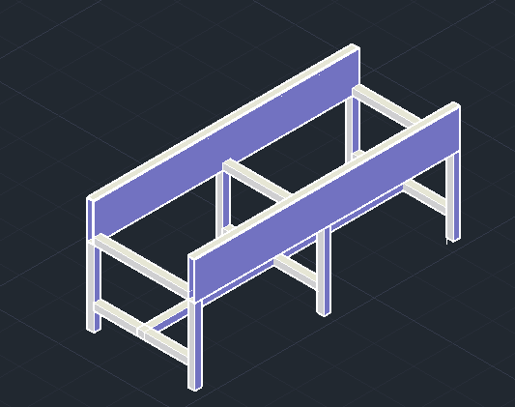

**Figure 4.1: Support table**

**4.2 Pulley:**

Usually there two types of pulley are used according to the drive system

1. Head drive pulley
2. Tail drive pulley

Pulley is used to drive the belt conveyor during the operations. Diameter of the pulley is depended on the width of the belt. Here diameter of pulley considered as 150 mm.

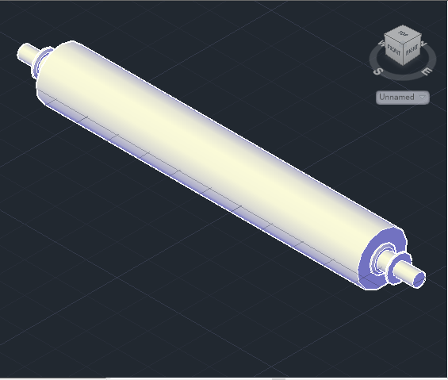

**Figure 4.2: Pulley**

**4.3 Support roller:**

Rollers are used to convey the belt with loads from beginning to end of the entire distance. Roller also reduces the friction of the conveyor system. The diameter of the roller is 38 mm**.**

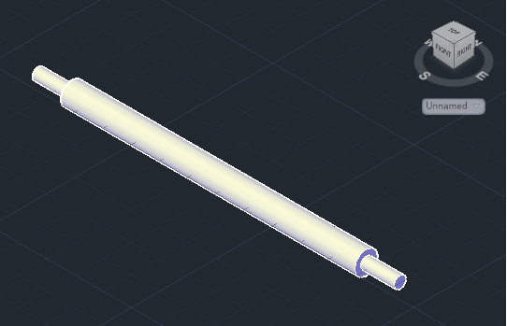

**Figure 4.3: Support roller**

**4.4 Tension device:**

Tension device is used to control the tension of the belt. It also helps to rotate the belt conveyor through the system.

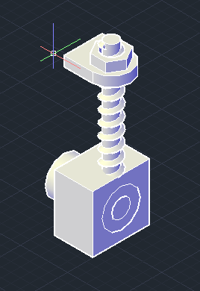

**Figure 4.4: Tension device**

**4.5 Belt:**

There are many types of belt usually used such as rubber belts, fabrics belts etc. Diameter of the belt is 400 mm and it is a fabric belt. (Polyester)

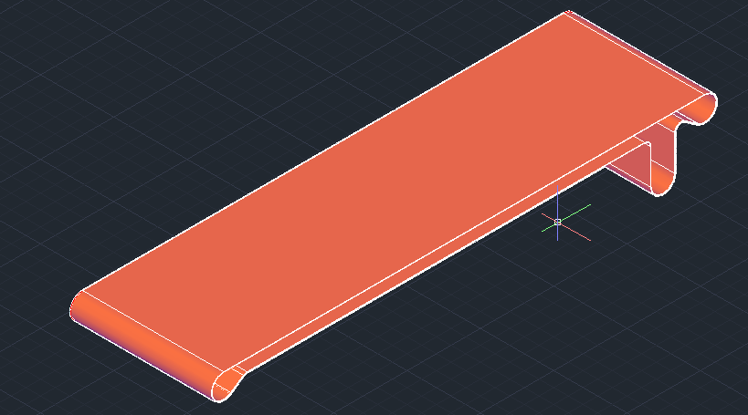

**Figure 4.5: Belt**

**4.6 Assembly of belt conveyor:**

Figure (4.6) and (4.7) are shown below the assembly of various components of belt conveyor.

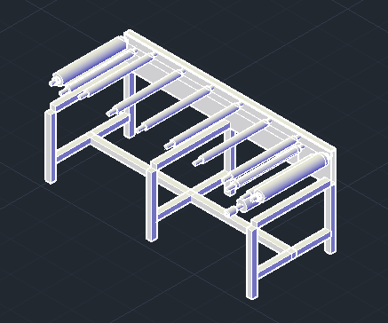

**Figure 4.6: Assembly of rollers and pulleys**

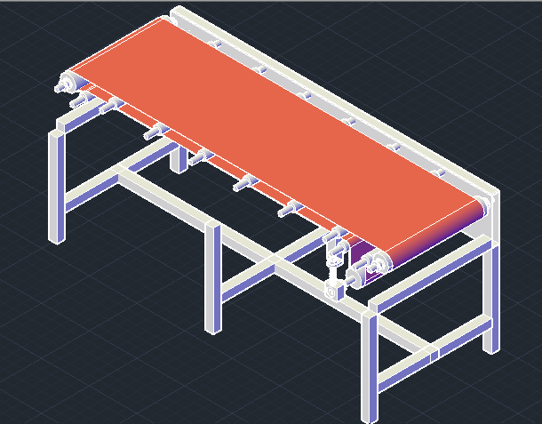

**Figure 4.7: Assembly with belt**

**4.7 Belt conveyor:**

This is the belt conveyor that was designed and also calculates various parameters above. Motor will include the opposite side of the tension device.

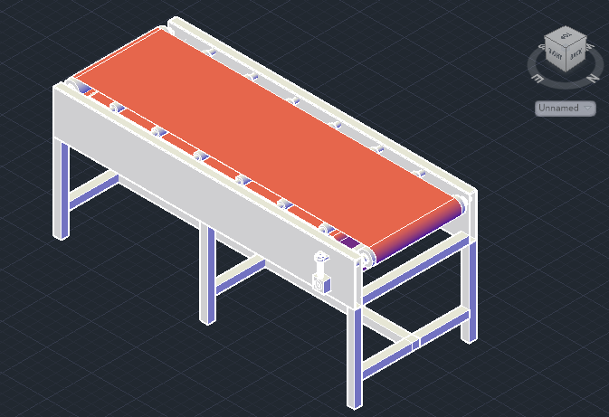

**Figure 4.8: Belt conveyor**

**CHAPTER 5**

**5. Study of Failure Analysis**

**5.1 Drum and Pulley Failure:**

**5.1.1 Typical failure and processing:**

The explanation of typical failure forms of roller and conveyor are analyzed, and the maintenance methods of preclusion and exclusion of failures to ensure the normal action of belt conveyor are explained. [17]

**5.1.2 Fracture in collapsed heavy-duty pulley:**

Fracture of pulley is generally analyzed by FEM and fracture macro examination is performed with use of following formulas: Sf = 32.FS.Mb/π D3. (0.5 SUT) where,

Sf is estimated fatigue limit to the pulley

FS is the safety factor,

Mb the bending moment and

D the shaft diameter

SUT the material tensile strength. [18]

**5.1.3 Conveyor Pulley Shaft Failures:**

The reason for failures of shafts in a conveyor pulley in iron-making unit at JSW Steel has been investigated. Visual, metallographic, chemical, and fractographic studies were carried out. Fracture studies shows that shaft failed in shear because of overload. [19]

**5.1.4 Analysis of conveyor pulley using FEM:**

The primary analysis of pulley parts has been helpful in arriving at some broad design rules and stresses and deflections of its various parts has been described for reliable design of pulley by using FEM. [20]

**5.1.5 Fatigue Failures of Welded Conveyor Drum:**

An elastic analysis shows that high cyclic bending stresses were formed at the plate-boss welds when the drums were loaded by the tension in the conveyor belt and Fatigue cracks initiated at the toes of the welds between the plates and the bosses, and propagated through the plates until the shell became separated from the shaft. [21]

**5.1.6 Fatigue in the shell of a conveyor drum:**

The shells of a belt conveyor broke in action due to fatigue in the area of the weld seam between the axle disk and the cylindrical shell due to overloading of drum and compare the original design with actually manufactured drum. [22]

On the basis of researches the variation in causes of failures in drum or pulley as shown in bar chart:

|  |
| --- |
| Percentage of Drum failure 🡪  Cause of Failure |
| **Figure 5.1:** Percentage in causes of drum failure in Belt Conveyor System |

**5.2 Belt design and its failure:**

**5.2.1 Vibrations with Low and Time-Varying Velocity:**

By using Kirchhoff’s method an equation of motion will be derived from a coupled system of partial differential equations telling the longitudinal and transversal vibrations of the belt in varying load conditions. The results shows that the frequencies of the belt speed fluctuations play a major role in the dynamic behavior of the conveyor belt. [23]

**5.2.2 Conditions for field vulcanizing with a better capability of elongation:**

By using analysis of mean of the Taguchi method, the optimum settings for field vulcanizing a fabric conveyor belt with a better capability of elongation were obtained at different environmental conditions. The optimum conditions includes (1) curing time of 25 min, (2) curing pressure of 9 kg/cm2, (3) dismantling platen temperature of 90 ˚C and (4) forced cooling of air. [24]

**5.2.3 Eco-design of non-metallic layer composites for belts:**

The methods for designing multilayer conveyor belts can be evaluated by using SimaPro 5 software and optimizing the strength properties regarding various belts and their on the environment during operation. This includes Belt Materials with Nanostructure fillers appear to have a more promising effect on the performance of the conveyor belt composite to adapt innovative performance characteristics. [25], [26]

**5.2.4 Belt Tension around a Drive Drum:**

A mechanical model is established to simulate the starting of a drive drum with a distributed mass-spring system for the belting. The model creates the tension distribution in the belt around the drum face including necessities for visco elastic contraction when designing a drive system. [27]

**5.3 Accident frequency:**

**5.3.1 According to conveyor location:**

**Table 5.1:** Accident percentage according to conveyor location

|  |  |
| --- | --- |
| **Location** | **Percentage** |
| 1. Between the drive pulley, head pulley or tail pulley 48% and the belt, inside one of these pulleys or between one of these pulleys another pulley. | 48% |
| 1. Between an idler or a return idler and the belt. | 13% |
| 1. Other locations (e.g., between electromagnets and other components.) | 13% |
| 1. Drum motor transmission mechanism. | 7% |
| 1. Between a take-up pulley and the belt. | 5% |
| 1. Between a caught tool and the belt or the conveyor frame. | 2% |
| 1. Not indicated or uncertain. | 12% |

**5.3.2 Worker Activity:**

**Table 5.2:** Accident percentage according to worker activity

|  |  |
| --- | --- |
| **Worker Activity** | **Percentage** |
| 1. Cleaning a pulley or applying adhesive on a pulley or cleaning another component of a conveyor (idler or return idler, frame). | 24% |
| 1. Maintenance work (other than cleaning conducted on a moving conveyor.) | 20% |
| 1. Normal work (e.g., sorting, packaging) performed on or near a conveyor | 11% |
| 1. Recovering an article caught in an unprotected nip point | 9% |
| 1. Cleaning under or around a conveyor. | 7% |
| 1. Maintenance work (other than cleaning) near a moving conveyor | 6% |
| 1. Un jamming the conveyor or removing an accumulation of material | 5% |
| 1. Adjusting the belt tension or alignment | 4% |
| 1. Other activities (e.g., worker being transported by a conveyor). | 4% |
| 1. De-icing and un jamming a frozen belt. | 1% |
| 1. Not indicated. | 9% |

**CHAPTER 6**

**6. Maintenance and Safety of Belt Conveyor:**

**6.1 Maintenance (Repair):**

Maintenance and service shall be executed by skilled, qualified personnel only. Where lack of maintenance and service would source a risky situation, the user shall form a maintenance program to ensure that conveyor components are maintained in a condition that does not establish a risk to personnel. No maintenance or service shall be accomplished when a conveyor is in operation. See “Lubrication” and “Adjustment or Maintenance during Operation” for exceptions. When a conveyor is stopped for maintenance or service, the starting devices, head driver, powered accessories or electrical must be locked / tagged out in agreement with a formalized procedure designed to protect all persons or groups involved with the conveyor against an unexpected restart. Personnel should be notified to the hazard of stored energy, which may exist after the power source is locked out. All safety devices and guards shall be replaced before starting equipment for normal operation. [28]

**6.2 Adjustment During Operation:**

When adjustments or maintenance must be done while equipment is in operation, only skilled, qualified personnel who are aware of the hazards of the conveyor in motion shall be allowed to make modifications, perform maintenance or service. Conveyors shall not be maintained or serviced while in operation unless proper maintenance or service requires the conveyor to be in motion. If conveyor operation is required, personnel shall be made aware of the hazards and how the task may be safely accomplished. [28]

**6.3 Lubrication**

Conveyors shall not be lubricated while in running unless it is impractical to shut them down for lubrication. Only skilled and qualified personnel who are aware of the hazards of the conveyor in motion shall be allowed to lubricate a conveyor that is operating.

Where the drop of lubricants or process liquids on the floor constitutes a hazard, drop pans or other means of eliminating the hazard must be provided by purchaser(s). [28]

**6.4 Guards And Safety Devices:**

Guards and safety devices shall be maintained in a workable and operational condition. Warning signs are the obligation of the owner of the conveyor and must be maintained in a legible / operational condition. [28]

**6.5 Inspections:**

Schedule inspections with preventative and /or corrective maintenance programs shall be conducted to confirm that all safety features and devices are maintained and function properly. All personnel shall inspect for hazardous conditions at all times. Remove sharp edges or protruding objects. Repair or replace worn or damaged parts immediately. [28]

**6.6 Cleaning:**

Where light cleaning and/or casing cleaning are required, they shall be performed by skilled personnel. The conveyor electrical power must be turned off and locked / tagged out following machine specific procedures**.** Special attention may be required at feed and discharge points. [28]

**6.7 Safety Warning:**

Replace all safety devices, guards and guarding prior to equipment start-up.[28]

Safety Labels for Conveying Equipment:



**6.8 Maintenance Schedules:**

If equipment repair or replacement is required during inspections, thoroughly review the manufacturer’s specific product information for correct procedure.

**6.8.1 Daily Maintenance:**

* Inspect all conveyors to ensure that all guarding is securely in place.
* Inspect belt tracking for at least (3) full belt revolutions.

**6.8.2 Weekly Maintenance:**

* Inspect conveyor for loose bolts and set screws.
* Inspect bearings, gear reducers, motors and chains for excessive noise or heat.
* Inspect belt to ensure that there is not excessive wear and that all splices are intact.
* Inspect belt tension. The tension should be enough to:
  + Prevent slippage between drive pulley (sheaves for spurs) and belt under a full load.
  + Force belt to conform to the crown on crowned pulleys.
* Inspect rollers to ensure that they rotate freely without excessive noise.

**6.8.3 Monthly Maintenance:**

* Inspect oil level in reducer. Fill if necessary.
* Inspect reducer for leaking seals.
* Inspect conveyor for loose bolts.
* Inspect drive chains, jump chains and sprockets for wear, alignment and proper chain tension.
* Check guide system wheels to ensure all bearings are intact and wheel covers are not worn through on belt curves.
* Lubricate pulley shaft bearings.

**6.8.4 Quarterly Maintenance:**

* Grease all pulley shaft bearings.
* Inspect conveyors for worn or broken drive belts. Replace as necessary. If belt shows signs of abrasion, check for hindrance with the belt or foreign object in the roller groove.

**6.8.5 Semi-Annual Maintenance:**

* Tighten all bearing set screws if not completely tight.

**6.8.6 Annual Maintenance:**

* Change oil in reducers. (If your conveyor is equipped with a Boston 700 Series Reducer, it is filled with oil, sealed and lubed for life thus requiring no oil changes. See manufacturer’s information for recommended lubricant at specific temperatures. This information is shipped with every reducer.) [28]

**CHAPTER 7**

**7. Discussion:**

Belt conveyor is now one of the best trendy material transporting systems in various industries. It conveys different types of materials or goods in the industries. The capacity of a belt conveyor is depends on some important factors and also on some valuable parameters. The capacity of belt conveyor is proportional to the belt speed, cross sectional area of the belt and the density of the conveyed goods or materials. To increase the capacity of a belt conveyor it is necessary to consider the tension of the belt while it is starting. The efficiency of the belt conveyor is also depends on the diameter of the drive pulley, power of the head drive, start up factors and also the power of the motor. The more the wrap angle of the belt with the pulley, it reduces the slippage of the materials.

When we design the belt conveyor we have considered both of the factors and the parameters of the belt conveyor system. In this thesis paper we tried to figure out the different types of values of the belt conveyor and also select the approximate diameters of the related parameters (such as pulley, support rollers, belt wide) according to the standard of the belt conveyor. Here we also focus on the selection of correct materials and all the costs of the entire design of the belt conveyor. It is also stated that we have experienced a lots of constraints to select the right equipment for the belt conveyor. It is suitable for mobile or light weight conveying like unit load. Basically, it was a project under the development of laboratory apparatus on our workshop. But due to monetary constraints we could not build the conveyor that we have designed. In summary, we did not execute our project but we designed the improved belt conveyor and carried out the thesis on this theme. In future this apparatus can be updated by including sensor, so that the weight of the conveyed goods or material can easily be evaluated. This requires the further analysis of the belt conveyor system.

**CHAPTER 8**

**8. Conclusions:**

It was discovered that there were some mechanical problems to design the belt conveyor and also determine the appropriate components for the unit load carrying belt conveyor. Such as the selection of the conveyor belt, support rollers, pulleys, motor etc. are meaningful to provide a high-quality belt conveyor. Many commonly occurred problems could be avoided by proper installation. Belt conveyor is now designing for industries like food, cement, garments etc. so the designing parameters are varied according to their application. In the food transfer and unit load transfer, belt must be non-reactive. Dust emission control system is required in coal and cement industries, fire & safety is main consideration in coal industries, but others parameters like pulley& belt failure, energy & efficiency, drive mechanism, friction and maintenance are common in all applications. So the most successful belt conveyor system design depends on maintenance& control, energy & efficiency control, equipment lethal accidents and pulleys & belt failures. To accomplish above requirement it is needed to be further suitable designing of conveyor system which is desired for the application keeping all parameters in mind and by inventing new approaches towards better design.

**References:**

[1] Mikell P. Groover (2008), Automation Production systems, and computer-Integrated Manufacturing.

[2]http://www.themhedajournal.org/2004/07/15/transport-of-bulk-materials-by-conveyor-dates-back-to-1795

[3] K Pathak Indian institute of technology kharagpur, “Belt Conveyor guide”

[4] “Conveyor Equipment Manufacturers Association (CEMA)”, “Belt Conveyors for Bulk Materials”, 6th Edition

[5] Elgun (1999)

[6] R. S. khurmi, J.K. Gupta, “Theory of Machine”

[7] Jiang, Guilan (2008) “Belt conveyor”

[8] Robert L. Mott, “Machine elements in mechanical Design”

[9] Unknown Writter, “Belt Conveyors, Operation & Maintenance in Cement Plant”

[10].Ogedengbe, T. I. (2010). Lecture Note on Applied Techniques of Production Management. pp. 16-20.

[11] Fenner Dunlop “Conveyor Handbook” (2009).

[12] [www.forbo-seigling.com](http://www.forbo-seigling.com) “Calculation methods – conveyor belts”

[13] Besser Service Bulletin. (2006). “Conveyor Belt Basic Rules

and Procedure for Tracking”

[14] Rulmeca, Technical information, “Project and Design Criteria for Belt conveyors”

[15] Sandvik (2000), “Conveyor Components”

[16] Orthman, “Conveying System” (2004). Belt Conveyor Catalogue.

[17] LihuaZHAO,YinLIN, “Typical failure analysis and processing of belt conveyor” (2011)

[18] J.A. Martins a, I. Kövesdy , I. Ferreira b, “Fracture analysis of collapsed heavy-duty pulley in a long-distance continuous conveyors application”, Elsevier Limited,(2009).

[19] D. Satish Kumar, PradeepAgarwal, “Investigation of Conveyor Pulley Shaft Failures”, ASM International, (2011)

[20] M.Ravikumar1, AvijitChattopadhyay, “Integral analysis of conveyor pulley using finite element method”, Elsevier Limited, “1999”.

[21] D. R. H. JONES, Fatigue Failures Of Welded Conveyor Drums, Elsevier Limited,(1995)

[22] Ch. Affolter , G. Piskoty, R. Koller, M. Zgraggen, T.F. Ru¨ tti, Fatigue in the shell of a conveyor drum, Elsevier Limited,(2007)

[23] G. SUWEKEN and W. T. VAN HORSSEN, On the Weakly Nonlinear, Transversal Vibrations of a Conveyor Belt with a Low and Time-Varying Velocity, Kluwer Academic Publishers,(2003)

[24] Chuen-Shii Chou a, Ching-Liang Liu, Chun-Sheng Tseng a, Optimum conditions for field vulcanizing a fabric conveyor belt with a better capability of elongation (2012)

[25] “KrystynaCzaplicka”, “Eco-design of non-metallic layer composites with respect to conveyor belts”, Elsevier Limited, (2003).

[26] “S. Falkenberg and L. Overmeyer”, Doping of Conveyor Belt Materials with Nano structured Fillers to Adapt Innovative Performance Characteristics, World Academy of Science, Engineering and Technology, (2009)

[27] A. Harrison, Modeling Belt Tension around a Drive Drum, bulk solids handling, (1998)

[28] Omni Metalcraft corp. “BELT TECHNICAL HANDBOOK” (2012).